

*Bachelor’s Degree in Bioinformatics (UPF-UPC-UB)*

*Final Grade Project*

|  |
| --- |
| **Elucidating drug-drug interactions underlying drug polypharmacy profiles**  Jorge Hernansanz1*, Cristina Leal1, Gianluca Mazzoni1, Søren Brunak1  1 Novo Nordisk Foundation Center for Protein Research, Faculty of Health and Medical Sciences, University of Copenhagen, Copenhagen DK-2200, Denmark.  *Correspondence: jorge.hernansanz@cpr.ku.dk  Abstract  **Background:** Drug-drug interactions (DDI) are a common characteristic of adverse drug reactions (ADR) and suppose an emerging threat to public health. DDI data remains disperse and its integration into a unique source can benefit other research for an easier access to data.  **Methods:** We generated a complete compendium of DDI data through the integration of 15 publicly available drug sources, and a recollection of the different DDI features (Clinical significance, evidence level, management options, mechanism of action, and side effects). We looked to the overall overlap of the DDIs and we analyzed each source by looking to its drug and DDIs. Finally, we performed a network cluster analysis with our compendium to a drug combination clinical data in order to find significant DDI in clinical data according to the clinical significance information obtained from the sources.  **Results:** Across our databases, there are 4.288 unique drugs and 2.560.648 unique DDIs. We concluded a limited overlap of DDIs between our sources, and observed a bias for some of the ATC class in specific databases focused on cardiovascular, HIV, Hepatitis and Cancer drugs. We found two highly connected clusters from the network analysis performed on the drug combination clinical data.  **Conclusion:** There is little overlap between the different databases, indicating thus the sparsity information across DDI interaction databases. Disease-specific databases contains limited DDI information of certain drug classes. A network analysis approach was used for elucidating clinically significant DDI (major, moderate and minor) in hospital clinical data from Denmark.  **Keywords:** Drug-drug interactions, WHO-ATC identifiers, DDI characterization, network analysis  **Supplementary information:** Here it will go a link of GitHub that I will pass to my coordinators with what I have generated (Needed for the evaluation). The part of clinical data will not be added there. |

1. **Background**

A DDI occurs when one drug modifies the pharmacological activity of other drugs. DDI is a common characteristic of adverse drug reactions (ADR) [1], which is the focus of pharmacovigilance [2]. DDIs can be divided into two major groups, pharmacokinetic interactions, which involves changes in the absorption, distribution, metabolism and excretion of the drugs [3], and pharmacodynamics interactions; in which directly one drug changes the pharmacological effect of another one being additive or antagonist [4].

DDI data can be found in both public website sources (Drugbank, Crediblemeds…) and private commercial sources (Lexicomp, Stockley’s drug interactions…). Current DDI can be used to train statistical models that predicts new DDIs. Some DDI extraction challenges were hold in the past with the goal of covering different approaches when extracting DDI data from biomedical texts [5] [6]. Also, other projects evaluated the performance of unsupervised and supervised machine learning methods for predicting potential DDIs [7]. The integration of DDIs into a common consensus is still a challenge. Previous studies have already tried to integrate multiple DDI databases [8] [9]. In a society where, co-administration of drugs is becoming more and more frequent, a synthesis of this knowledge would help clinicians guide patients to effective and less noxious medication therapies [10].

In this paper, we extracted all DDI data from 15 publicly available databases; Drugbank, KEGG,

NDF-RT, Twosides, Interaktion Databasen, Crediblemeds, ONC-High, ONC-Non interruptive, HIV, HEP, CANCER, DDI Corpus 2011, DDI Corpus 2013, PK Corpus and NLM CV Corpus, and gather all of them by mapping each drug to a common identifier; the ATC code. We provided a complete DDI dataset with a total of 3.049.224 DDIs. We used the information collected as a tool for exploratory analysis of DDIs. Finally, we used our compendia to characterize and elucidate common patterns of DDI from a clinical setting.

This work provides a useful and important resource to be used in the pharmacovigilance field.

1. **Methods**
   1. **Anatomical therapeutical classification**

Anatomical Therapeutic Chemical (ATC) Classification System is a drug-related ontology that classifies within different levels the chemical group of each drug. Each drug may have several ATC codes but there is only one drug for each ATC code. It consists of 14 different anatomical groups, each of them reaching 5 different levels of differentiation.

|  |  |  |  |  |  |  |
| --- | --- | --- | --- | --- | --- | --- |
| **Source** | **Description** | **Clinical significance** | **Management options** | **Evidence level** | **Mechanism of**  **action** | **Side effect** |
| Drugbank x | | | | | | |
| KEGG |  |  | x |  | x |  |
| Interaktion Databasen |  | x | x | x |  |  |
| Twosides |  |  |  |  |  | x |
| NDF-RT |  | x |  |  |  |  |
| Crediblemeds | x |  | x |  | x |  |
| HIV | x | x |  | x |  |  |
| HEP | x | x |  | x |  |  |
| CANCER | x | x |  | x |  |  |
| DDI Corpus 2011 | x |  |  |  |  |  |
| DDI Corpus 2013 | x |  |  |  |  |  |
| NLM CV Corpus | x |  |  |  |  |  |
| PK Corpus | x |  |  |  |  |  |
| ONC HIGH |  | x | x | x |  |  |
| ONC NI |  |  |  | x |  |  |

The ATC classification system is developed and maintained by the World Health Organization Collaborating Center (WHOCC) [11] for drug statistics methodology.

* 1. **Overview of DDI sources**

We created a drug-drug interaction dataset using content from 15 openly available databases. Seven of them (Drugbank, KEGG, Twosides, Interaktion Databasen, HIV, HEP and CANCER), are continuously updated.

**Table 1.** List of DDI sources and the extracted information of each of them

We collected for each database specific features related to DDI pairs (Table 1). From a total of 15 public databases, we extracted six specific DDI features: i) *description* consist of unstructured text that describes how the interaction affects the drugs involved; ii) *clinical significance* feature associates to the DDI the level of change in the physiological effect of the drugs affected. ; iii) evidence level gives an estimation of how well documented is that DDI based on a reference classification for Liverpool Interactions [12]; iv) *management* specifies the modalities to follow when drugs are prescribed in combination; v) *mechanism of action* indicates the target/s involved leading to the DDI; vi) *side effect* states the adverse reaction induced by the DDI.

Clinical significance, evidence level, and management features were considered as ordinal variables in order to keep factorized the information of the severity/significance.

Mechanism of action and side effect were also treated to be used in exploratory analyses. Mechanism of action output was formatted to a general vocabulary of actions easy to deal with. Side effect information was coded with the Medical Dictionary for Regulatory Activities (MedDRA) [13] identifier. MedDRA is the international medical terminology developed under the auspices of the International Council for Harmonization of Technical Requirements for Pharmaceuticals for Human use (ICH).

* + 1. **DrugBank**

The DRUGBANK database [14] is a unique bioinformatics and cheminformatics resource that combines detailed drug data with comprehensive drug target information. Information retrieval was performed with the R package “DBparsed” [15], obtaining a brief description for each DDI. The version used in this study

(5.0) was downloaded from the Drugbank website [16] on January 2020.

* + 1. **KEGG**

The KEGG DRUG database [17] is a comprehensive drug information resource for approved drugs in Japan, USA, and Europe. Information is unified based on the chemical structure and/or the chemical component of active ingredients. Information retrieval was performed from its REST API [18], such as drugs’ mechanism of action and management DDI (“Contraindicated”, “precaution”). The version used in this study (93.0) was downloaded in February 2020.

* + 1. **NDF-RT**

NDF-RT [19] is the National Drug File – Reference Terminology from the U.S. Department of Veteran Affairs, Veterans Health Administration (VHA). It is an extension of the VHA National Drug File (NDF) that combines its hierarchical drug classification with a multi-category reference model. “VA Drug interactions” was the category extracted, which contains clinical significance concept for each of the DDIs. The version used in this study dates from July 2014 as this was the last release VA was maintaining NDF-RT interactions, resulting in its removal from their posterior updates. Data was downloaded from the National Institutes of Health (NIH) repository [20] in March 2020.

* + 1. **Twosides**

The Twosides project [21] consists of a comprehensive database of DDI side effects. Twosides reports a total of 40 million DDI-related side effects, with their corresponding propensity scores for the evidence level. We downloaded the dataset from their lab repository [22] in February 2020.

* + 1. **Crediblemeds**

Crediblemeds [23] is a clinically oriented information source that is used to guide clinical decision-making and safe use of drugs with risk of QT prolongation and/or torsades de pointes (TdP). Crediblemeds comprises a small DDI dataset and contains information such as Precipitant and Object drugs, as well as mechanism of action and management options features for each of the DDIs. The newest version of it dates from May 2010 with no identifiers.

* + 1. **Interaktion Databasen**

The Danish DDI database [24] is an electronic search tool that describes evidence-based interactions documented by clinical/case studies. It provides a common frame of reference for the on the handling of drug interactions in the Danish healthcare system. Data was retrieved from a public document provided by the Danish Medicines Agency [25]. Information provided includes clinical significance, evidence level, and management administration features for each DDI. The version used in this study (XML-dato-3 release 2.7) was downloaded in March 2020.

* + 1. **ONC High-priority/ Non-interruptive**

ONC High-Priority (ONC-High) [26] consists of a set of high-severity DDIs for use in electronic health records (EHR). This dataset is characterized by contraindicated and clinically significant DDIs. Nevertheless, most of the DDIs included in this resource lack of primary literature supporting their evidence. We retrieved information regarding clinical significance, evidence level, and management options features. It is a one-time updated project published in April 2012.

ONC Non-Interruptive (ONC-NI) [27] consists of a set of low priority DDIs feasible for non-interruptive alerts that aims to reduce alert fatigue for the provider’s workflow of EHRs. We retrieved information regarding the clinical significance and evidence level features. Like ONC-High, this is also a one-time updated project published in September 2012.

These two projects come from research organized by the Office of The National Coordinator for Health Information Technology (ONC) where in both cases the set of DDIs was a consensus between the different commercial drug providers that participated.

* + 1. **DDI Corpus 2011/2013**

DDI Corpus 2011 [5] relates to a project included in the DDI Extraction 2011 workshop focused on natural language processing (NLP) techniques for drug-drug extraction from text selected from the Drugbank database. This project dates to September 2011.

DDI Corpus 2013 [6] relates to a project included in the SemEval 2013 DDI Extraction challenge for the evaluation of NLP techniques applied to recognition of pharmacological substances and drug-drug extraction from Drugbank and Medline databases. This project dates to July 2013.

Isabel Segura’s Lab carried out both projects and its raw data can be accessed from her own GitHub [28].

* + 1. **NLM CV Corpus**

NLM CV Corpus [29] is a DDI corpus used for training NLP techniques that identifies possible DDIs where cardiovascular drugs are involved.

* + 1. **PK Corpus**

PK Corpus [30] is a specific-pharmacokinetic DDI corpus from a pharmacokinetic ontology used for DDI text mining analysis in drug product labels.

**2.2.11 University of Pittsburgh**

Data from DDI Corpus 2011/2013, the NLM CV Corpus and PK corpus have been previously processed by Ayvaz project [8] by mapping drug names to Drugbank identifiers. Therefore, DDI datasets were extracted from the GitHub of the Department of Biomedical Informatics of the University of Pittsburgh [31] in February 2020.

* + 1. **Liverpool Interactions**

HIV/HEP/CANCER drug interactions [32] [33] [34] correspond to three clinical evidence-based DDI resources from the Liverpool university. Liverpool interactions report clinical significance between a selected number of disease-specific drugs and a bigger set of standardized drugs, independently of the

* Data was obtained from the Github of the Department of Biomedical Informatics from the University of Pittsburgh [31]

** As one-time updated source, version comes from the month it was published.

|  |  |  |  |  |  |
| --- | --- | --- | --- | --- | --- |
| **Source** | **No** | **of drugs** | **No of DDIs** | **Owner** | **Version** |
| Drugbank | 3.779 | | 2.255.390 | Drugbank.ca | 5.1.0 |
| KEGG | 2.963 | | 206.875 | Kanehisa laboratories | 93.0 |
| Interaktion Databasen | 932 | | 18.691 | Danish Medicine Agency | 2.7 |
| Twosides | 1.951 | | 351.647 | Nicholas Tatonetti | 11/2019 |
| NDF-RT | 1.144 | | 12.199 | Veteran health administration | 07/2014 |
| Crediblemeds | 163 | | 403 | Crediblemeds.org* | 05/2010** |
| HIV | 1.339 | | 50.138 | Liverpool University | 04/2020 |
| HEP | 1.339 | | 41.011 | Liverpool University | 03/2020 |
| CANCER | 1.021 | | 66.707 | Liverpool University | 09/2019 |
| DDI Corpus 2011 | 846 | | 4.664 | Isabel Segura - Bedmar* | 01/2011** |
| DDI Corpus 2013 | 1.307 | | 10.857 | Isabel Segura - Bedmar* | 10/2013** |
| NLM CV Corpus | 458 | | 2.861 | National Library of Medicine* | 01/2011** |
| PK Corpus | 451 | | 3.211 | Richard D.Boyce* | 02/2013** |
| ONC HIGH | 195 | | 2.865 | ONC* | 04/2012** |
| ONC NI | 509 | | 21.705 | ONC* | 09/2012** |

presence of interaction with other drugs. We extracted

**Table 2:** List of DDI sources. For each one it contains the number of drugs and DDIs that were mapped to the ATC code. It also contains the owner of each source and the version used in our project.

information related to the clinical significance and the evidence level for each DDI. The three of them were downloaded in April 2020.

* 1. **Parsing DDI pairs**

Each database contains different type of information and structured in a different way. Therefore, to integrate databases together each dataset was parsed and the information mapped to the others using specific procedures.

DrugBank and KEGG codify drugs with their own type of identifier, and provide a complementary section of data that links to ATC codes. This complementary section of DrugBank was also used for the 4 corpus: DDI Corpus 2011, DDI Corpus 2013, PK Corpus, and NLM CV Corpus, Crediblemeds dataset, and the ONC projects, that were already encoded with Drugbank identifiers.

NDF-RT uses its own type of identifier without specifying the ATC code. To map the drug names to an ATC code we used a comprehensive repository of biomedical ontologies called BioPortal [35] that provided us for indexes to parse the NDF-RT identifier to the Concept Unique Identifier (CUI), and from CUI to ATC code.

Interaktion Databasen encodes its drugs and every

other component with its own identifiers. For the mapping procedure it was used a CSV file retrieved from the Danish Medicine Agency that accounts for the ATC code for each drug identifier stored in the database.

Twosides uses the RXNORM identifier for its drugs, which is the normalized clinical drug dictionary of the Unified Medical Language System (UMLS). It did not provide us with a direct link to the ATC code, so we retrieved form BioPortal an index to parse RxNorm to CUI identifier, and used the previous index retrieved of CUI – ATC identifier.

HIV, HEP and CANCER interactions consists of three online websites where drugs are reported with regular drug names. Therefore, drugs were name-linked to Drugbank identifiers to assign them the corresponding ATC code. Drugs that were not mapped to DrugBanks were manually annotated using as index the WHO ATC list of 2017.

* 1. **Clinical data**

In order to elucidate DDI on clinical data, we collected drugpairs from actual prescription data from electronic health records (EHR) covering the period January 2008 to June 2016 from Denmark. The clinical data contained drug pairs information including the number of patients and the age distribution. All possible pairwise combinations were compared for finding the coverage of DDIs in our compendia.

* 1. **Visualization tools**

Overlap analysis between our sources was carried out with upsetR [36], an R package that visualize the

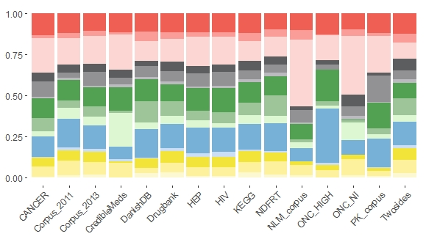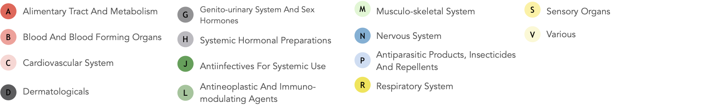

**Figure 1.** Percentage barplot distribution of drugs for each database according to the first ATC level.

different interaction intersections between sources, showing a range from the interactions that are unique for each database, to those ones that are covered by most databases.

For the visualization of the interaction distribution for each database, we used an R package called “Circlize” [37] that gives the distribution desired in a circular layout.

* 1. **Network analysis**

We performed a network analysis using Cytoscape [38], an open source software platform used for visualizing and integrating networks. We used the MCODE algorithm [39], which is a graph theoretic-based clustering algorithm with three stages: network weighting, complex detection and optional post-processing. This cluster algorithm detects densely connected regions in large interaction networks. Although it has been primarily used for protein-protein interactions, its use for DDI can help us identify significant drug clusters.

Parameters were personalized for our analysis. “Degree cutoff” was set to 2 in order to prevent single-connected nodes in clusters. We represented the clinical drug pairs as a directed network and as 2 drugs may share 2 edges, the “K-Core” parameter was set to 3 to force each node to have 3 connections per node and to connect at least with 2 drugs. Following the FAQ section of MCODE [40] it is stated to apply the “MCODE level 3” parameters in case of seeking for dense interconnected clusters. This changed parameter “Node Score Cutoff” to 0.1, “fluff” to zero, and disabling “haircut” option.

1. **Results**

General descriptive statistics for each drug source including unique number of drugs with corresponding DDI pairs are reported in Table 2.

* 1. **Characterizing DDIs**

An overlapping analysis was performed to our compendia to visualize in how many sources each DDI was observed [S1]. We found our DDI data to have a limited overlap where we can observe that the vast majority of DDIs appear only in one, two, or three databases [S2]. There were very few DDIs appearing in higher degree intersections, being all of them covered by DrugBank, and most of them by KEGG and Twosides sources [S3]. The highest degree of overlapping achieved by our compendia is of nine databases with only five DDIs in that section.

A characterization analysis, according to the first ATC level, was run inside each database. We checked the distribution of each type of drug across databases (Figure 1) and the intersection of DDIs across database [S4].

Regarding the distribution of drugs, we observed

that the databases follow a similar one where the level 1 ATC class most relevant corresponds to the Cardiovascular System drugs (C). In addition, Nervous System drugs (N) and Antiinfectives for Systemic Use drugs (J) have a major overall prevalence among most of classes. Some databases account for a more detailed distribution of drugs. For example, the

NLM CV Corpus and ONC NI have a bigger proportion of Cardiovascular System drugs (C). This is expected from the first one as it is used to identify DDIs in drug product labeling affecting cardiovascular

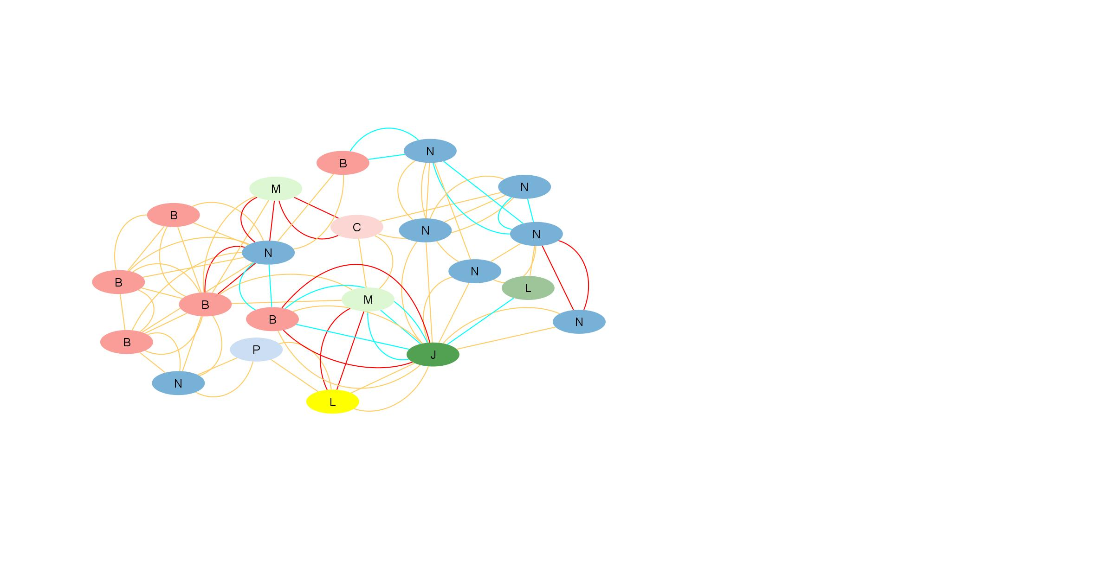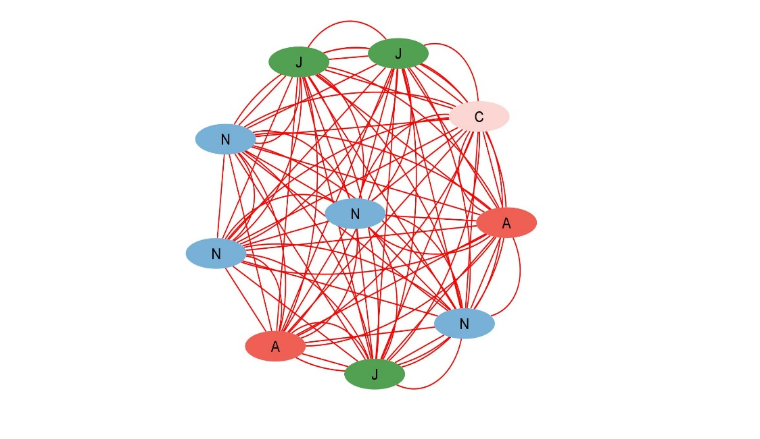

**Figure 2.** Clusters obtained from MCODE algorithm. Clinical significance levels are categorized with colors where blue, yellow, and red are associated to minor, moderate, and mayor level respectively. It is only displayed the first ATC code level in order to preserve the privacy of the clinical data.

drugs [8]. In contrast, Crediblemeds contains a higher degree of Musculo-skeletal System (M) drug-related interactions compared to the rest of databases.

Looking at the distribution of interactions inside each database, we observe again that the most predominant ATC class correspond to the one of Cardiovascular System. Both NLM CV Corpus and ONC-NI display a big set of ATC class C receiving most of interactions from the rest of classes. Interestingly, in Crediblemeds, most drugs from ATC class J are interacting with the class C and that ATC class M, although having a good percentage of drugs inside the database, plays an insignificant role at the interactions of the source. We also observe predominance of ATC class J for HIV and HEP, and ATC class L for CANCER, where all interactions are likely to interact with them.

* 1. **Cluster analysis**

We represented in a network how clinical DDIs are distributed according to their clinical significance: minor, moderate and major interactions [S5]. DDIs were filtered to actual drug pair prescriptions, allowing the analysis to have a real implementation in a clinical environment. We considered the anatomical level of the ATC classification and ranked the clinical significance of interactions in four levels (0, 1, 2, 3), ranging from 0 when a DDI is not expected to have pharmacokinetic changes to 3 when a DDI represents a major change in the pharmacokinetics of one of the drugs. For the purpose of our analysis, DDIs with a score of zero were removed.

We found two relevant clinical DDI clusters (Figure 2). The first cluster consisted of 10 nodes and 90 edges, all of them with a clinical significance level 3,

indicating a total major level of interactions between them. This cluster is characterized predominantly by nervous system drugs (N).

The second cluster we identified is less dense and more heterogeneous from a clinical point of view, 10 nodes and 12 edges for mayor level, 21 nodes and 53 edges for moderate level, and 9 nodes and 13 edges for minor level. All the nodes from this cluster have interactions that correspond to the moderate ones. The ATC level N remains again as the class that groups more nodes in the cluster.

1. **Discussion**

Up to day there is still a limited overlap between the different publicly DDI sources available on the internet. Moreover, this project did not cover all existing databases and DDI knowledge such as new interaction pairs continues appearing, indicating the necessity of a continuous work to have a well-updated Compendia.

Network analysis revealed a small cluster of mayor type interaction between its drugs. We used TRANSFORMER [41], a web tool that checks interactions between drugs and phase I (such as cytochromes) and II enzymes and transporters, to check for the mechanism of action of these drugs and find similarities. We observed nine of them are highly interacting with cytochromes 1A2, 2D6 and 3A4, and the other one does not present any cytochrome interaction.

1. **Conclusion**

In this project, we integrated a wide range of publicly available sources of DDI information. We analyzed the overlap across the different databases to observe how well DDIs were covered between them.

Then, we looked to the distribution of drugs and the interactions, based on the first ATC level, for each of the databases and checked for significant patterns.

Finally, we performed a cluster analysis on the elucidated clinical DDI using clinical significance information.

Although more exhaustive analyses are needed, this study confirms that a more complete DDI dataset integrating different available sources it is necessary to detect potential significant patterns.

As future work, this project may continue with the assignment of extracting more DDI sources, and be used as to complement for other research papers.

1. **Acknowledgement**

I would like to show my gratitude to my supervisors Cristina Leal and Gianluca Mazzoni for all the time spent tutoring me and giving me the opportunity to learn about the pharmacology field and treating me like a researcher, to my research director Søren Brunak for the meetings held along with my supervisors, and to the rest of people I met at CPR for showing me a great research environment.

1. **Supplementary files**

S1. UpsetR plot showing the total DDI intersections observed between the data sources.

S2. UpsetR plot showing the DDI intersections covered by 1, 2 and 3 sources.

S3. UpsetR plot showing the DDI intersections covered by 7, 8 and 9 sources.

S4. Circlize plot showing the distribution of DDIs according to their first ATC level for each database.

S5. Plot of the network analysis including clusters.

1. **References**
2. Montastruc F, Sommet A, Bondon-Guitton E, et al. The importance of drug-drug interactions as a cause of adverse drug reactions: a pharmacovigilance study of serotoninergic reuptake inhibitors in France. European Journal of Clinical Pharmacology. 2012 May;68(5):767-775. DOI: 10.1007/s00228-011-1156-7.
3. Lopes P, Nunes T, Campos D, Furlong LI, Bauer-Mehren A, Sanz F, et al. (2013) Gathering and Exploring Scientific Knowledge in Pharmacovigilance. PLoS ONE 8(12): e83016. <https://doi.org/10.1371/journal.pone.0083016>
4. Palleria C, Di Paolo A, Giofrè C, et al. Pharmacokinetic drug-drug interaction and their implication in clinical management. J Res Med Sci. 2013;18(7):601‐610.
5. Niu J, Straubinger RM, Mager DE. Pharmacodynamic Drug-Drug Interactions. Clin Pharmacol Ther. 2019;105(6):1395‐1406. doi:10.1002/cpt.1434
6. Segura-bedmar, I. (2011). Proceedings of the 1st Challenge task on Drug-Drug Interaction Extraction. Proceedings of the 1st Challenge Task on Drug-Drug Interaction Extraction, January.
7. Herrero-Zazo, M., Segura-Bedmar, I., Martínez, P., & Declerck, T. (2013). The DDI corpus: An annotated corpus with pharmacological substances and drug-drug interactions. Journal of Biomedical Informatics, 46(5), 914–920. <https://doi.org/10.1016/j.jbi.2013.07.011>
8. Kastrin, A., Ferk, P., & Leskošek, B. (2018). Predicting potential drug-drug interactions on topological and semantic similarity features using statistical learning. PLoS ONE, 13(5), 1–23. <https://doi.org/10.1371/journal.pone.0196865>
9. Ayvaz, S., Horn, J., Hassanzadeh, O., Zhu, Q., Stan, J., Tatonetti, N. P., Vilar, S., Brochhausen, M., Samwald, M., Rastegar-Mojarad, M., Dumontier, M., & Boyce, R. D. (2015). Toward a complete dataset of drug-drug interaction information from publicly available sources. Journal of Biomedical Informatics, 55(May), 206–217. <https://doi.org/10.1016/j.jbi.2015.04.006>
10. Peters, L. B., Bahr, N., & Bodenreider, O. (2015). Evaluating drug-drug interaction information in NDF-RT and DrugBank. Journal of Biomedical Semantics, 6(1). <https://doi.org/10.1186/s13326-015-0018-0>
11. Hines, L.E., Malone, D.C. and Murphy, J.E. (2012), Recommendations for Generating, Evaluating, and Implementing Drug‐Drug Interaction Evidence. Pharmacotherapy, 32: 304-313. doi:[10.1002/j.1875-9114.2012.01024.x](https://doi.org/10.1002/j.1875-9114.2012.01024.x)
12. WHO Collaborating Centre for Drug Statistics Methodology, ATC classification index with DDDs, 2020. Oslo, Norway 2019.
13. <https://liverpool-hiv-hep.s3.amazonaws.com/QoE_Info_HIV_Oct2017.pdf>
14. Brown, E. (2007). Medical Dictionary for Regulatory Activities (MedDRA®). Pharmacovigilance: Second Edition, 20(September 1998), 168–183. https://doi.org/10.1002/9780470059210.ch13
15. Wishart, D. S., Feunang, Y. D., Guo, A. C., Lo, E. J., Marcu, A., Grant, J. R., Sajed, T., Johnson, D., Li, C., Sayeeda, Z., Assempour, N., Iynkkaran, I., Liu, Y., MacIejewski, A., Gale, N., Wilson, A., Chin, L., Cummings, R., Le, Di., … Wilson, M. (2018). DrugBank 5.0: A major update to the DrugBank database for 2018. Nucleic Acids Research, 46(D1), D1074–D1082. <https://doi.org/10.1093/nar/gkx1037>
16. Mohammed Ali, Ali Ezzat (). dbparser: DrugBank Database XML Parser. R package version 1.1.3.9000.
17. <https://www.drugbank.ca/releases/latest>
18. Kanehisa, M., Goto, S., Furumichi, M., Tanabe, M., & Hirakawa, M. (2009). KEGG for representation and analysis of molecular networks involving diseases and drugs. Nucleic Acids Research, 38(SUPPL.1), 355–360. <https://doi.org/10.1093/nar/gkp896>
19. <https://www.kegg.jp/kegg/rest/keggapi.html>
20. Olvey, E.L., Clauschee, S. and Malone, D.C. (2010), Comparison of Critical Drug–Drug Interaction Listings: The Department of Veterans Affairs Medical System and Standard Reference Compendia. Clinical Pharmacology & Therapeutics, 87: 48-51. doi:10.1038/clpt.2009.198
21. <https://evs.nci.nih.gov/ftp1/NDF-RT/>
22. Tatonetti NP, Ye PP, Daneshjou R, Altman RB. Data-driven prediction of drug effects and interactions. Sci Transl Med. 2012;4(125):125ra31. doi:10.1126/scitranslmed.3003377
23. <http://tatonettilab.org/resources/nsides/>
24. <https://www.crediblemeds.org/healthcare-providers/drug-drug-interaction>
25. <https://laegemiddelstyrelsen.dk/en/sideeffects/danish-drug-interaction-databases/~/media/C779D15E4FC5483EB23C39CFFD04C57E.ashx>
26. <https://laegemiddelstyrelsen.dk/en/sideeffects/danish-drug-interaction-databases/>
27. Phansalkar, S., Desai, A. A., Bell, D., Yoshida, E., Doole, J., Czochanski, M., Middleton, B., & Bates, D. W. (2012). High-priority drug-drug interactions for use in electronic health records. Journal of the American Medical Informatics Association, 19(5), 735–743. https://doi.org/10.1136/amiajnl-2011-000612
28. Phansalkar, S., van der Sijs, H., Tucker, A. D., Desai, A. A., Bell, D. S., Teich, J. M., Middleton, B., & Bates, D. W. (2013). Drug-drug interactions that should be noninterruptive in order to reduce alert fatigue in electronic health records. Journal of the American Medical Informatics Association, 20(3), 489–493. <https://doi.org/10.1136/amiajnl-2012-001089>
29. <https://github.com/isegura/DDICorpus>
30. Johann Stan, A Machine-Learning Approach for Drug–Drug Interaction Extraction from FDA Structured Product Labels, Presented at the 2014 National Library of Medicine Training Conference, Pittsburgh PA, USA, 17-Jun-2014.
31. Wu, H., Karnik, S., Subhadarshini, A. et al. An integrated pharmacokinetics ontology and corpus for text mining. BMC Bioinformatics 14, 35 (2013). https://doi.org/10.1186/1471-2105-14-35
32. <https://github.com/dbmi-pitt/public-PDDI-analysis>
33. <https://www.hiv-druginteractions.org/checker>
34. <https://www.hep-druginteractions.org/>
35. <https://cancer-druginteractions.org/>
36. Musen MA, Noy NF, Shah NH, Whetzel PL, Chute CG, Story MA, Smith B; NCBO team. The National Center for Biomedical Ontology. J Am Med Inform Assoc. 2012 Mar-Apr;19(2):190-5. Epub 2011 Nov 10.
37. Jake R Conway, Alexander Lex, Nils Gehlenborg, UpSetR: an R package for the visualization of intersecting sets and their properties, Bioinformatics, Volume 33, Issue 18, 15 September 2017, Pages 2938–2940, <https://doi.org/10.1093/bioinformatics/btx364>
38. Zuguang Gu, Lei Gu, Roland Eils, Matthias Schlesner, Benedikt Brors, circlize Implements and enhances circular visualization in R. Bioinformatics (Oxford, England) 2014.
39. Paul Shannon, 1, Andrew Markiel, 1, Owen Ozier, 2 Nitin S. Baliga, 1 Jonathan T. Wang, 2 Daniel Ramage, 2, Nada Amin, 2, Benno Schwikowski, 1, 5 and Trey Ideker2, 3, 4, 5 (1971). Cytoscape: A Software Environment for Integrated Models. Genome Research, 13(22), 426. <https://doi.org/10.1101/gr.1239303.metabolite>
40. Bader, G.D., Hogue, C.W. An automated method for finding molecular complexes in large protein interaction networks. BMC Bioinformatics 4, 2 (2003). <https://doi.org/10.1186/1471-2105-4-2>
41. <https://omics.bjcancer.org/pina/help/PINA_MCODE_FAQ.pdf>
42. Michael F. Hoffmann, Sarah C. Preissner, Janette Nickel, Mathias Dunkel, Robert Preissner and Saskia Preissner.  
    [The Transformer database: biotransformation of xenobiotics.](http://www.ncbi.nlm.nih.gov/pubmed/24334957/)  
    Nucleic Acids Res. 2014 Jan 1;42(1):D1113-7. doi: 10.1093/nar/gkt1246. Epub 2013 Dec 10.